Excel file for the below exercises: <https://drive.google.com/file/d/1J0Ejz5hErWDbx2TPZ8bEU0RN3pMmdCCP/view?usp=sharing>

1. **Question:**

From the given data file. Create a pivot able in a new worksheet which should show the product category and order category wise quantity sum

**Answer:**

Insert >> PivotTable >> select a table or range >> new worksheet >> create

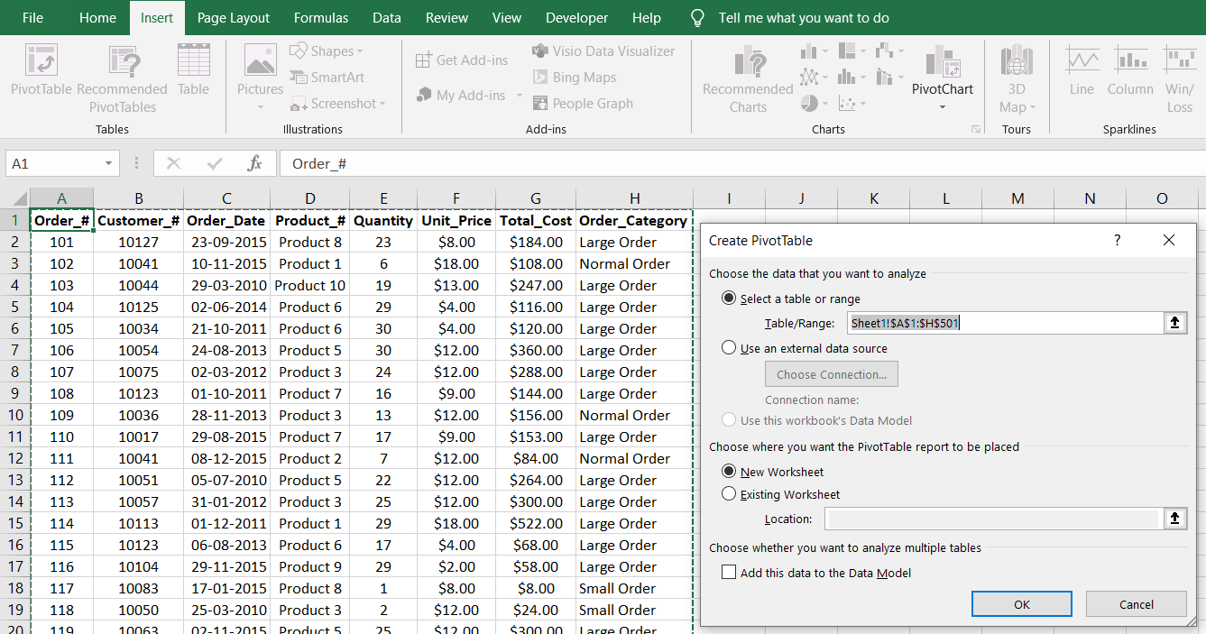

Drag quantity to the values field, order category to columns field, and product category to the rows field.

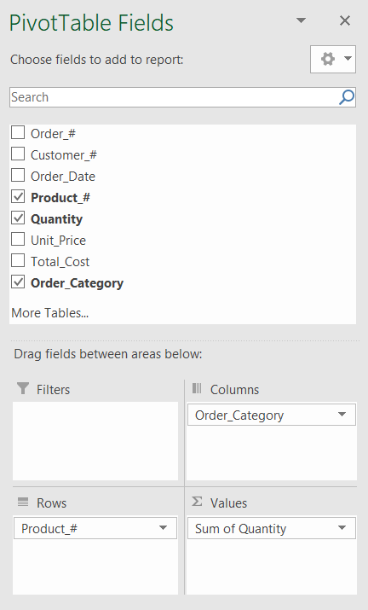 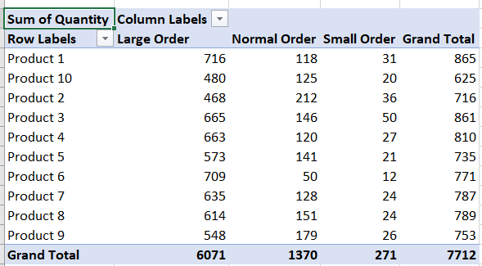

1. **Question**

<https://drive.google.com/file/d/1yhMGpDVpFILBs493IY_qOzA7Xdj9l-a6/view?usp=sharing>

Get the data file from the above link

And from the given data find the count of male and female customers in each country using pivot table

Answer:

Tot

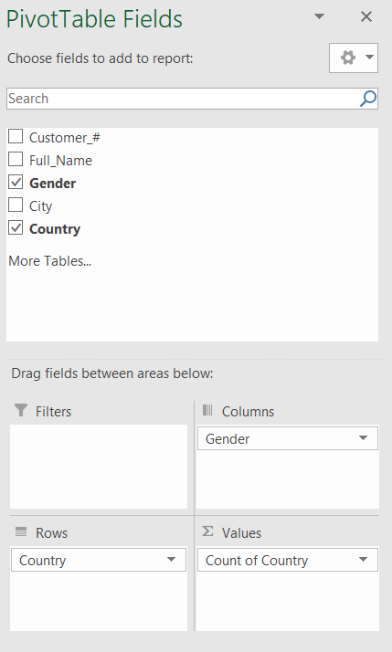 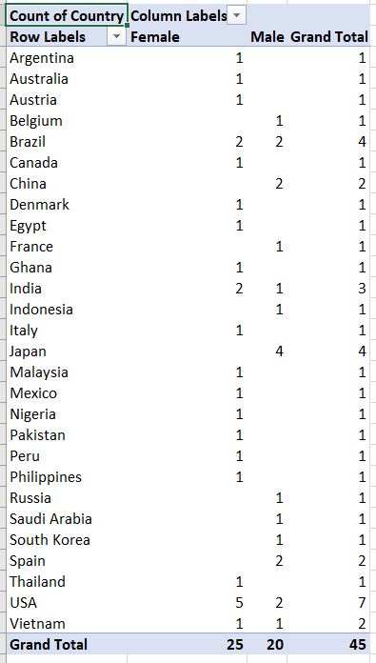

1. **Question:**

Download the data from <https://drive.google.com/file/d/1LMD2Hxkdbe6HPfbsW_0uBPGFZnxHwxaf/view?usp=sharing>

* Find the sum of quantity, sum of sales document and sum of sales USD by region wise for each company
* Create a pivot chart for sum of USD for each customer in every region

**Answer:**

sum of quantity, sum of sales document and sum of sales USD by region wise for each company

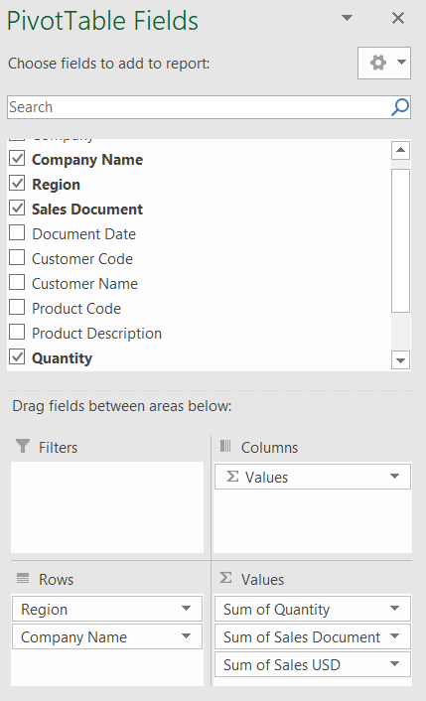

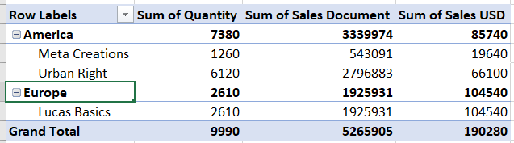

pivot chart for sum of USD for each customer in every region

